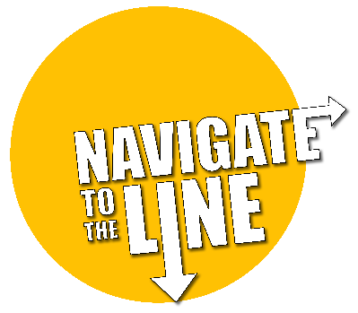

Safe balloon gas storage and use

The high-pressure cylinder of Balloon Gas provides the lifting gas for the Navigate To The Line aircraft. A single cylinder can fill several pairs of 1m diameter balloons to enable a challenge involving many students, especially when teams are encouraged to share balloons. With planning and testing of the lifting potential of Balloon gas, students can create their craft in advance and only need to have access to the Balloon Gas and inflated balloons for a short period of time.
About balloon gas and cylinders
Balloon gas is comprised primarily of the noble gas Helium with a few other light gases mixed in. It is non-toxic, and non-flammable and is safe to use in any well-ventilated area. The cylinders are the same as would be used at an eduation event where there are floating balloons or at a party shop selling floating inflatables.
The cylinders used are supplied for the period needed to complete the challenge and are delivered and recovered from the school by a BOC delivery service to a schedule agreed with a school contact.
General risks with high pressure helium cylinders.
- Explosion of the cylinder due to mechanical damage.
- Exposure to released gas.
- Over-pressurisation in the event of fire.
- Impact from falling cylinders.
- Manual handling injuries.
Balloon gas storage and handling advice from BOC.
- Balloon gas cylinders can rupture when heated in a fire.
- Store them in a well-ventilated, non-smoking area, away from other flammable materials and sources of ignition or heat.
- Store cylinders in an upright position and secure them to prevent toppling. Never turn your back on a free-standing tall cylinder. Trolleys and straps are available to secure cylinders.
- Cylinders stored in the open should stand on a well-drained, flat surface.
A lockable science storeroom with a door or ventilation brick to the outside would be fine. Where an outside cylinder cage is available, that can also be used. The cylinders can be secured from falling when stored with a strap or similar fixture.
A furniture trolley or similar can be used to move the gas cylinder between rooms although balloons can be inflated in a central location and taken to where they will be used, using tethers if going outside.
It is recommended that a teacher that has attend a Learning Partnership CPD session for Navigate To The Line take responsibility for inflating balloons, identifying the most appropriate storage location for the time the cylinder is on the school premises and for liaising with any local H&S responsible parties.
** NEVER PERMIT STUDENTS OR STAFF TO INHALE THE BALLOON GAS **
Operation of the gas cylinder with balloons
Cylinders are provided with a latex balloon adaptor to aid filling of the balloons.
This should be attached, but if supplied separately, then can be screwed on to the thread by hand (do not use tools to tighten the adaptor on the valve)

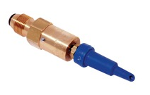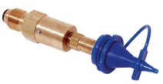
To prepare the balloons.
Helium molecules are very small and can escape through the latex membrane. A bottle of HiFloat latex treatment is provided to each school. Follow the instructions to inject 4 or 5 squirts of HiFloat into the neck of the balloon. Knead the balloon for a minute to ensure the HiFloat treatment covers all the interior surface of the balloon. After inflation, the liquid will dry and form a gas impermeable barrier that will greatly reduce the loss of balloon gas and enable a pair of balloons to be used for several days by teams sharing them.
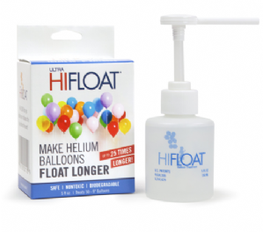
To use the inflation adaptors:
Open the main gas valve first. The adaptors release a supply of gas when pushed into the mouth of a balloon and pressed in or bent to the side.
When inflation is complete, close the main valve to prevent any leakage.

Do not overinflate
Do not inflate a balloon to a diameter in excess of 1m. Most aircraft will fly with balloons inflated to 70-80cm diameter. Using less gas will enable more teams to share more balloons. The optimal balloon size can be determined by experiments (see Lesson Resources)

RISK ASSESSMENT: NAVIGATE TO THE LINE WORKSHOP
ACTIVITY | PERSON AT RISK | SIGNIFICANT HAZARDS | RISK*  L S DR |  |  | RISK CONTROL MEASURES | RISK*  L S DR
Storage and use of Balloon gas | Staff members and others in the vicinity | Explosion, physical injury, asphyxiation | 1 | 5 | 5 | - Store cylinders not in use, in a ventilated, lockable storeroom or walk in cupboard. A cylinder cage can be used if available.  - Fill balloons in the secure store and take them to classes  - Secure tall cylinders with a chain to prevent them falling  - Do not work in a very small, unventilated space with a cylinder  - Keep the cylinders away from flames and other high heat sources | 1 | 1 | 1
Setting up | As above | Slips, trips and falls | 3 | 2 | 6 | - Use correct manual handling techniques when moving heavy gas cylinders, etc.  - Maintain a clear work area  - Ensure the area is kept tidy & wires for glue guns and laptops do not present a trip hazard | 1 | 2 | 2
Prior to activity | Staff and students | Cuts from moving parts or tools. | 2 | 2 | 4 | - Ensure that the aircraft have a reasonable sized space in which to operate that is not open to the air or draughty.  - Provide resources that allow for the safe cutting of wires  - Provide plastics or foam materials to make propeller shields  - Make students aware of risks from fast moving model propeller blades. Ensure they know how to make a shield or cowling for a propeller. | 2 | 1 | 2
Assembling and operating craft | As above | Hot glue burns & flying object impact injuries. Falls | 2 | 3 | 6 | - Mark and use hot glue gun areas with PAT tested glue guns.  - Ensure spectators stand clear of the flying area to avoid potential flying objects  - Do not use ladders or climb on structures to recover lost aircraft without help or supervision.  - Tidy area before observers can use the area for normal activity | 1 | 1 | 2
* Numbers used are for illustrative purposes only. ** Residual risk is the level of risk that remains after suitable and sufficient control measures are introduced.
LIKELIHOOD (L) = Frequent (5), Probable (4), Occasional (3), Improbable (2), Remote (1) SEVERITY (S) = Catastrophic (5). Major (4), Reportable (3), Serious (2), Minor (1) Degree of Risk (DR) = LIKELIHOOD x SEVERITY
Person/s completing document
Signatures/s
Position
Time and date completed

